Okay we are irst thinking abourt how would the data look like so
Basically desiging the data base table and their relation a table is basically a data structure that have rows and columns not much different o what we know
First of all what information we need to remember
First we have a user
From the user we need basic information from
Email
Password
Name
id
I think we need to have permessions as roles then we can have a column for each role and in this we write the document id of what documens he have what role in

A document
Id
Its content
Created at
Updated at
Maybe versions?
Ofc title and owner id

Okay it is a better design to have permessions as a separate table that have like
id, user id, document id and role

okay at first I had the question why do we need to have a versions table and I realized version are more complicated than to have its own column
before I look at it lets think what do I need in a versions table first of all ofcours the document id but hw arewe gonna store the documents will it be separate documents as separate version or are we gonna store the content of each version ? hmmmmmmmmm

content is currently stored as text image supoourt is expcted son and if needed we are gonna store the url for the iamge and the image will be stored In aws or smth like that

okay that’s the final decision for what tables we are gonna use
User
----
id
name
email
password
role ← system-wide (admin, regular user)
created_at

Document
--------
id
title
content ← stored as JSONB
owner_id ← links to User
created_at
updated_at

Permission
----------
id
user_id ← links to User
document_id ← links to Document
role ← "editor", "viewer", "commenter"

Version
-------
id
document_id ← links to Document
content ← full copy of document at that moment
version_number← 1, 2, 3...
created_by ← links to User
created_at

AI Interaction
--------------
id
document_id ← links to Document
user_id ← links to User
selected_text
action ← "summarize", "translate", "rewrite"
suggestion
status ← "accepted", "rejected", "partial"
created_at

we just learned that postgresql isn’t real time but its possible to make it real time by adding another real time layer to work with
but supabase fix that automatically in a way still under research
atm iam still learning what is an ER diagram
we decided to choose supabase because neondb postrgsql doesn’t have a websocket layer so subapase makes it easier

now working on the ER diagram and deciding the relation

https://mermaid.ai/d/bbf2eecb-abc4-48a4-8566-5706e64696c3

okay lock in again now we are thinking about the actions that the user can do
ofcours they can register login create document write edit document add people to their document and change their permessions make different versions of a document ( not sure yet how will this be implpmented) what else what else ahhhh

so we are deciding end point for example we have different operations
POST → create something
GET → read something
PUT → update something
DELETE → delete something

And we decide what is sent and what is recived
And also we learnt that a token is used in asession to know that this person is that person
And when we are getting a document we only get the meta data we don’t return the content that’s a lot

End points :
Auth
POST /auth/register
POST /auth/login
POST /auth/logout

Documents
GET /documents
POST /documents
GET /documents/{id}
PUT /documents/{id}
DELETE /documents/{id}

Permissions
GET /documents/{id}/permissions
POST /documents/{id}/permissions
PUT /documents/{id}/permissions/{user_id}
DELETE /documents/{id}/permissions/{user_id}

Versions
GET /documents/{id}/versions
GET /documents/{id}/versions/{version_number}
POST /documents/{id}/versions/restore/{version_number}

FULL CONTRACTS:
POST /auth/register
Receives:
{
"name": "John Doe",
"email": "john@example.com",
"password": "password123"
}
Returns:
{
"id": 1,
"name": "John Doe",
"email": "john@example.com",
"created_at": "2026-02-01T10:00:00"
}
Errors:
400 → email already exists
400 → missing required fields
POST /auth/login
Receives:
{
"email": "john@example.com",
"password": "password123"
}
Returns:
{
"token": "eyJhbGciOiJIUzI1NiIsInR5cCI6IkpXVCJ9...",
"user": {
"id": 1,
"name": "John Doe",
"email": "john@example.com"
}
}
Errors:
401 → wrong email or password
400 → missing fields
POST /auth/logout
Receives: nothing
Returns:
{
"message": "Logged out successfully"
}
Errors:
401 → not logged in
GET /documents
Receives: nothing
Returns:
{
"documents": [
{
"id": 1,
"title": "My Document",
"owner_id": 1,
"created_at": "2026-02-01T10:00:00",
"updated_at": "2026-02-01T10:00:00"
}
]
}
Errors:
401 → not logged in
POST /documents
Receives:
{
"title": "My New Document"
}
Returns:
{
"id": 1,
"title": "My New Document",
"content": {},
"owner_id": 1,
"created_at": "2026-02-01T10:00:00",
"updated_at": "2026-02-01T10:00:00"
}
Errors:
401 → not logged in
400 → title is missing
GET /documents/{id}
Receives: nothing
Returns:
{
"id": 1,
"title": "My Document",
"content": {},
"owner_id": 1,
"created_at": "2026-02-01T10:00:00",
"updated_at": "2026-02-01T10:00:00"
}
Errors:
401 → not logged in
403 → no permission
404 → not found
PUT /documents/{id}
Receives:
{
"title": "Updated Title",
"content": {}
}
Returns:
{
"id": 1,
"title": "Updated Title",
"content": {},
"updated_at": "2026-02-01T10:00:00"
}
Errors:
401 → not logged in
403 → no permission
404 → not found
DELETE /documents/{id}
Receives: nothing
Returns:
{
"message": "Document deleted successfully"
}
Errors:
401 → not logged in
403 → not the owner
404 → not found
GET /documents/{id}/permissions
Receives: nothing
Returns:
{
"permissions": [
{
"user_id": 2,
"user_name": "Jane Doe",
"role": "editor"
}
]
}
Errors:
401 → not logged in
403 → no permission
404 → not found
POST /documents/{id}/permissions
Receives:
{
"user_id": 2,
"role": "editor"
}
Returns:
{
"user_id": 2,
"document_id": 1,
"role": "editor"
}
Errors:
401 → not logged in
403 → not the owner
404 → not found
400 → user already has permission
PUT /documents/{id}/permissions/{user_id}
Receives:
{
"role": "viewer"
}
Returns:
{
"user_id": 2,
"document_id": 1,
"role": "viewer"
}
Errors:
401 → not logged in
403 → not the owner
404 → permission not found
DELETE /documents/{id}/permissions/{user_id}
Receives: nothing
Returns:
{
"message": "Access removed successfully"
}
Errors:
401 → not logged in
403 → not the owner
404 → permission not found
GET /documents/{id}/versions
Receives: nothing
Returns:
{
"versions": [
{
"id": 1,
"version_number": 1,
"created_by": 1,
"created_at": "2026-02-01T10:00:00"
}
]
}
Errors:
401 → not logged in
403 → no permission
404 → not found
GET /documents/{id}/versions/{version_number}
Receives: nothing
Returns:
{
"id": 1,
"document_id": 1,
"version_number": 1,
"content": {},
"created_by": 1,
"created_at": "2026-02-01T10:00:00"
}
Errors:
401 → not logged in
403 → no permission
404 → version not found
POST /documents/{id}/versions/restore/{version_number}
Receives: nothing
Returns:
{
"message": "Document restored to version 1",
"document": {
"id": 1,
"title": "My Document",
"content": {},
"updated_at": "2026-02-01T10:00:00"
}
}
Errors:
401 → not logged in
403 → no permission
404 → version not found

Now for C4level 1 system context diagram

https://mermaid.ai/d/bbf2eecb-abc4-48a4-8566-5706e64696c3
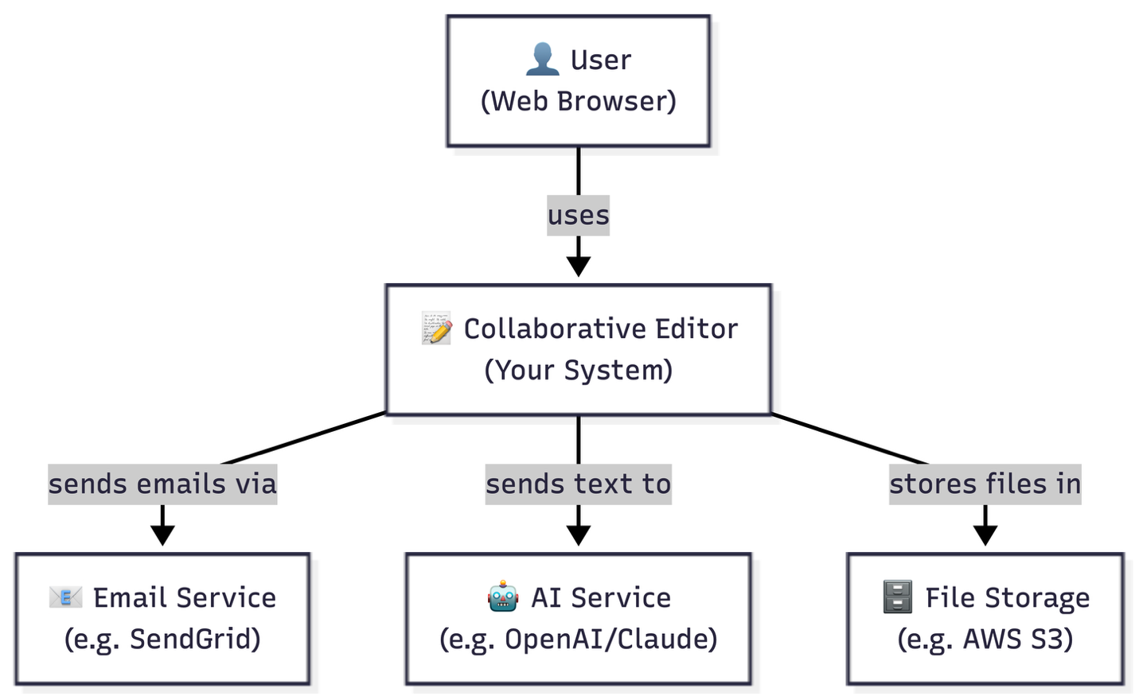

This diagram shows the Collaborative Editor system and its
relationships with external actors. Users interact with the
system through a web browser. The system communicates with
an Email Service for sending verification and notification
emails, an AI Service for powering the writing assistant
features, and a File Storage service for storing document
attachments and images.

Level 2 — Container Diagram

https://mermaid.ai/d/f56f302d-e0c9-4ce7-ba58-55116bcd49c6
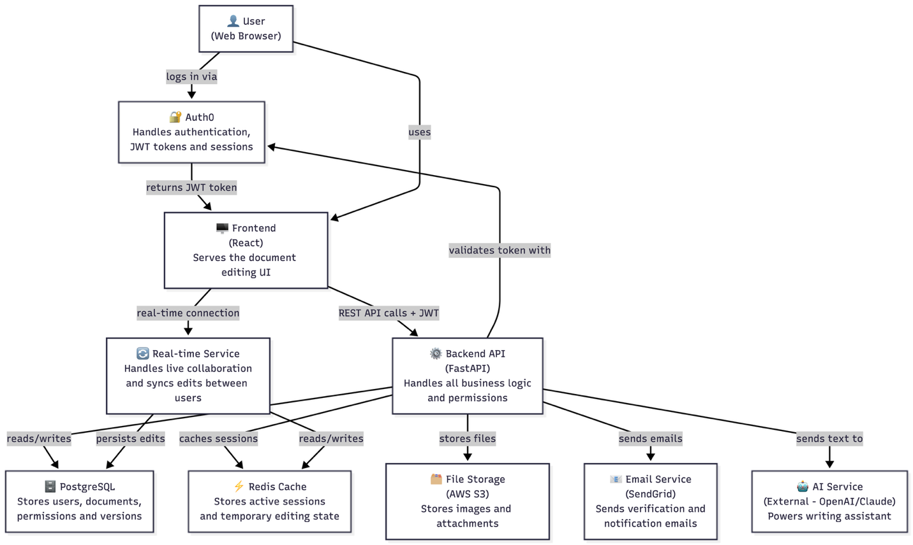
This diagram shows the major containers inside the Collaborative Editor system. The Frontend serves the document editing interface and maintains a real-time connection for live collaboration. Auth0 handles all authentication including login, registration, JWT token generation and session management. The Backend API built with FastAPI handles all business logic and validates JWT tokens with Auth0 on every request. PostgreSQL stores all persistent data. Redis Cache stores active sessions and temporary editing state for fast access. The Real-time Service syncs edits between connected users. AWS S3 handles file storage, SendGrid handles emails, and an external AI Service powers the writing assistant.
Level 3 — Component Diagram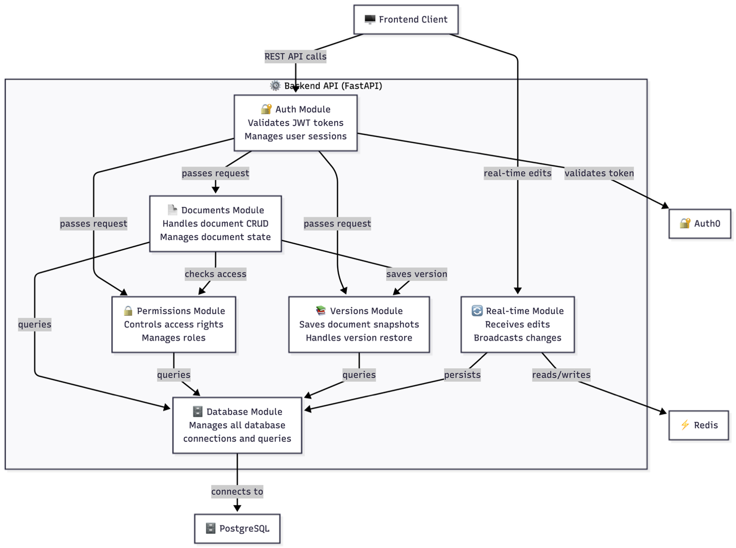
https://mermaid.ai/d/42c01386-1f5e-4863-9a61-d12cc0dd0f66
This diagram shows the internal components of the Backend API. Every incoming request first passes through the Auth Module which validates the JWT token with Auth0. The Documents Module handles all document operations and communicates with the Permissions Module to verify access rights before performing any action. The Versions Module is triggered by the Documents Module whenever a document is saved, creating a new snapshot. The Real-time Module handles incoming edits from connected users, stores temporary state in Redis for speed, and persists final changes to PostgreSQL through the Database Module.

1. Auth Module
What it does:
Validates JWT tokens on every incoming request.
Confirms the user's identity before passing the
request to any other module.

What it depends on:
Auth0 (external) for token validation

What it exposes:
A middleware function that other modules use to
protect their endpoints. Returns the current
user's id and role to the requesting module.

2. Documents Module
What it does:
Handles all document operations including creating,
reading, updating and deleting documents. Manages
document state and triggers version snapshots on
every save.

What it depends on:
Auth Module (to verify identity)
Permissions Module (to verify access)
Versions Module (to save snapshots)
Database Module (to persist data)

What it exposes:
Document CRUD endpoints:
GET /documents
POST /documents
GET /documents/{id}
PUT /documents/{id}
DELETE /documents/{id}

3. Permissions Module
What it does:
Controls who can access which document and at
what level. Manages roles (owner, editor,
commenter, viewer) and enforces access rules
on every document operation.

What it depends on:
Auth Module (to verify identity)
Database Module (to persist permissions)

What it exposes:
Permission management endpoints:
GET /documents/{id}/permissions
POST /documents/{id}/permissions
PUT /documents/{id}/permissions/{user_id}
DELETE /documents/{id}/permissions/{user_id}

Also exposes a checkPermission() function used
by the Documents Module before any operation.

4. Versions Module
What it does:
Saves full snapshots of a document every time
it is saved. Allows users to view version history
and restore any previous version.

What it depends on:
Auth Module (to verify identity)
Permissions Module (to verify access)
Database Module (to persist versions)

What it exposes:
Version management endpoints:
GET /documents/{id}/versions
GET /documents/{id}/versions/{version_number}
POST /documents/{id}/versions/restore/{version_number}

Also exposes a saveVersion() function triggered
by the Documents Module on every save.

5. Real-time Module
What it does:
Handles live collaboration between users editing
the same document. Receives edits from connected
users, broadcasts changes to all other users in
the same document session, and persists final
changes to the database.

What it depends on:
Auth Module (to verify identity)
Redis Cache (for fast temporary state)
Database Module (to persist final edits)

What it exposes:
A real-time connection endpoint that the frontend
connects to for live collaboration. Broadcasts
document changes to all connected users.

6. Database Module
What it does:
Manages all database connections and queries.
Acts as the single point of contact between
all other modules and PostgreSQL. Handles
connection pooling and query optimization.

What it depends on:
PostgreSQL (external)

What it exposes:
Database connection and query functions used
by all other modules. No endpoints exposed
directly to the frontend.

1. Who are the users?
Regular User ← anyone who registers and uses the app
Admin ← manages the system, can see all documents

2. What roles exist?
System-wide roles (stored in User table):
- Admin ← manages the whole system
- Regular User ← standard user

Document-level roles (stored in Permission table):
- Owner ← created the document, full control
- Editor ← can read and write
- Commenter ← can read and add comments only
- Viewer ← can only read

3. What can each role do?
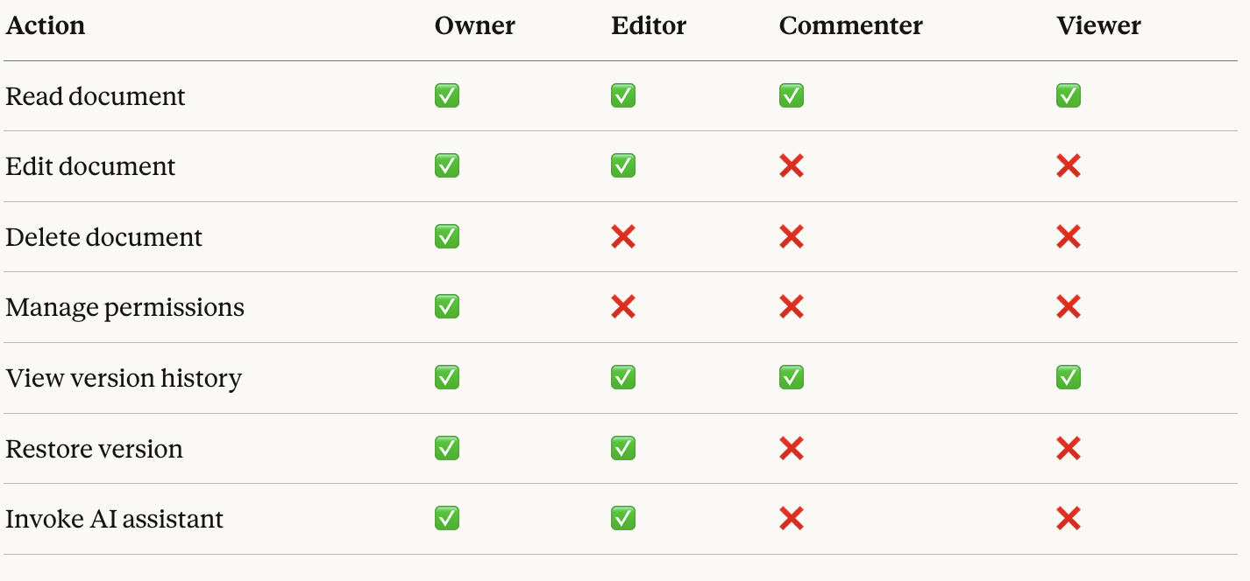
4. How does it work technically?
Step 1 → User logs in via Auth0
Step 2 → Auth0 returns a JWT token
Step 3 → Frontend stores the token
Step 4 → Frontend sends token with every request
Step 5 → Backend validates token with Auth0
Step 6 → Backend checks document-level permissions
Step 7 → Request is allowed or rejected

5. Privacy considerations:
- Document content sent to AI Service is sensitive
- Users must be informed their content may be
processed by a third party AI service
- AI interaction logs should have a retention
policy (e.g. deleted after 90 days)
- Passwords are never stored — Auth0 handles this
- JWT tokens expire after a set time for security
- All communication is encrypted via HTTPS

Communication Model
1. Approach
The system uses WebSockets via Yjs for real-time
communication. Unlike polling where the frontend
repeatedly asks the server for updates, WebSockets
maintain a persistent connection between the client
and server, allowing instant bidirectional communication.
Yjs is chosen over raw WebSockets because it handles
conflict resolution automatically using CRDTs (Conflict
free Replicated Data Types), removing the need to build
custom conflict resolution logic.

2. How it works step by step:
Step 1 — User opens a document
Frontend establishes a WebSocket connection
to the Real-time Service via Yjs
Server registers the user as active on that document
Server sends the current document state to the user

Step 2 — User types something
Edit is captured by Yjs on the frontend
Yjs sends the change to the Real-time Service
Real-time Service broadcasts the change to all
other users connected to the same document
Their screens update instantly

Step 3 — Two users edit the same region simultaneously
Yjs handles this automatically using CRDTs
Both edits are merged without data loss
All users end up with the same final document

Step 4 — User disconnects
Server notices the connection dropped
Other users see the user go offline
All changes made while offline are queued

Step 5 — User reconnects
Yjs automatically syncs all missed changes
User sees the current state of the document
User rejoins the active session

3. What happens during server failure:
- Active editing sessions are stored in Redis
- If the Real-time Service goes down:
→ Users see a "reconnecting" message
→ Frontend queues all edits locally
→ When service recovers, queued edits are synced
- No data is lost because:
→ Redis persists active session state
→ PostgreSQL stores the last saved document state

4. Scaling:
- Each document session runs on the Real-time Service
- Redis allows multiple Real-time Service instances
to share session state
- This means we can add more Real-time Service
instances as the number of users grows

5
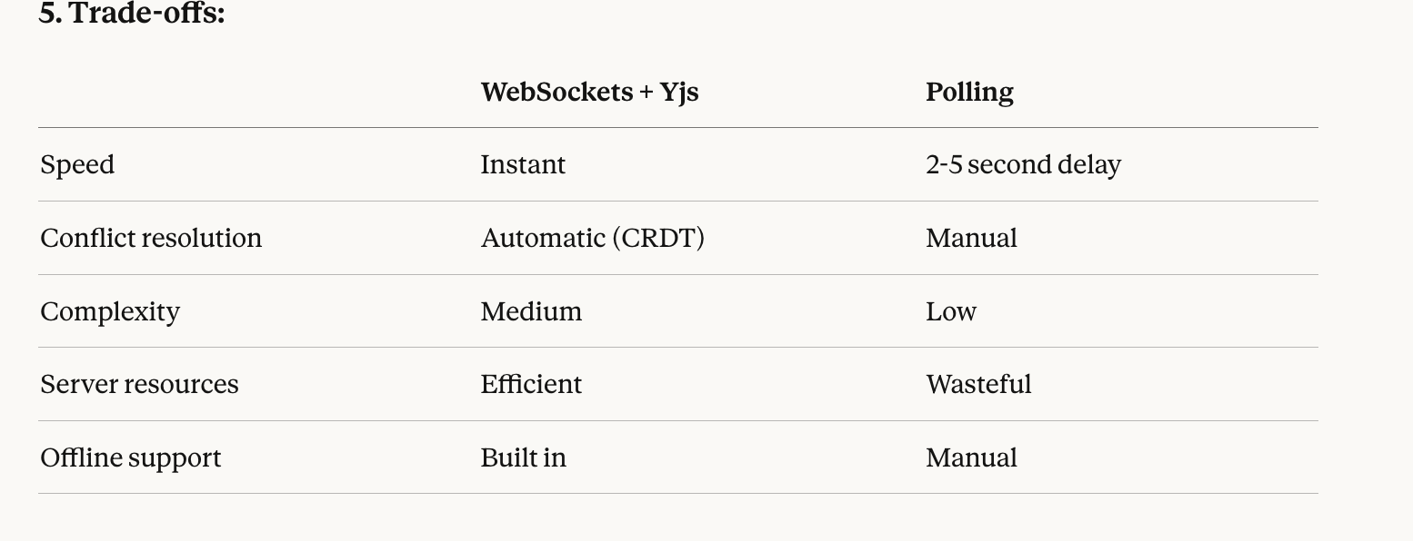

2.3 Code Structure & Repository Organization
1. Monorepo vs Multi-repo Decision
We chose a monorepo approach — keeping frontend,
backend, and shared code in one repository. This
decision was made because our team is small (4people),
we share type definitions between frontend and backend,
and it reduces overhead in managing multiple repositories.

2. Folder Structure
collaborative-editor/
│
├── frontend/
│ ├── src/
│ │ ├── components/ ← UI components
│ │ ├── pages/ ← app pages
│ │ ├── hooks/ ← react hooks
│ │ └── services/ ← API call functions
│ └── package.json
│
├── backend/
│ ├── app/
│ │ ├── main.py ← FastAPI entry point
│ │ ├── auth/ ← Auth module
│ │ ├── documents/ ← Documents module
│ │ ├── permissions/ ← Permissions module
│ │ ├── versions/ ← Versions module
│ │ ├── realtime/ ← Real-time module
│ │ └── database/ ← Database module
│ ├── tests/
│ │ ├── unit/ ← unit tests
│ │ └── integration/ ← integration tests
│ └── requirements.txt
│
├── shared/
│ └── types/ ← shared type definitions
│
├── .env.example ← environment variables template
├── .gitignore ← prevents secrets being committed
├── docker-compose.yml ← runs everything together
└── README.md

3. Shared Code
Shared type definitions live in the /shared directory.
This ensures that data contracts between frontend and
backend are defined once and never duplicated. For example,
the Document type is defined in /shared/types and imported
by both sides.

4. Configuration Management
All secrets and credentials are stored in a .env file
that is never committed to the repository. A .env.example
file documents what variables are needed without exposing
real values. This applies to database credentials, Auth0
keys, AWS S3 keys, and any third party API keys.

5. Testing Structure
Tests live in backend/tests and are split into two folders:
unit tests for testing individual functions in isolation,
and integration tests for testing endpoints end to end.
The AI service is always mocked in tests to avoid real
API calls, reducing cost and making tests reliable.

ADR 1 — Yjs for Real-time Collaboration
Title: Use Yjs for Real-time Collaboration

Status: Accepted

Context:
The system requires multiple users to edit the same
document simultaneously and see each other's changes
instantly. We need to handle conflicts when two users
edit the same region at the same time. We could build
this from scratch using raw WebSockets or use an
existing library.

Decision:
We chose Yjs as our real-time collaboration library.
Yjs uses CRDTs (Conflict-free Replicated Data Types)
to automatically resolve conflicts between simultaneous
edits without data loss.

Consequences:
Positive:
- Conflict resolution is handled automatically
- Built-in offline support and reconnection
- Saves weeks of building custom sync logic
- Battle tested in production apps

Negative:
- Additional dependency on external library
- Team needs to learn Yjs API
- Less control over conflict resolution behavior

Alternatives considered:
- Raw WebSockets: rejected because conflict resolution
would need to be built from scratch, adding significant
complexity and development time
- Socket.io: rejected because it handles connections well
but still requires manual conflict resolution logic
- Operational Transformation (OT): rejected because it is
significantly more complex to implement than CRDTs

ADR 2 — PostgreSQL as the Database
Title: Use PostgreSQL as the Primary Database

Status: Accepted

Context:
We need a database to store users, documents, permissions,
versions and AI interactions. We evaluated three options:
Firebase (NoSQL), Supabase (PostgreSQL as a service),
and Neon DB (serverless PostgreSQL). Our data has complex
relationships between users, documents and permissions
that need to be queried efficiently.

Decision:
We chose PostgreSQL hosted on Neon DB as our database.
PostgreSQL handles our relational data (users, permissions,
roles) naturally and supports JSONB for flexible document
content storage giving us the best of both worlds.
Neon DB was chosen over self-hosted PostgreSQL because
it is serverless, scales automatically, and requires no
infrastructure management.

Consequences:
Positive:
- Complex relational queries are simple and efficient
- JSONB support handles flexible document content
- Neon DB removes infrastructure overhead
- Strong consistency guarantees
- Easy to query permissions and roles

Negative:
- More complex than Firebase for simple use cases
- Neon DB adds external service dependency
- Team needs SQL knowledge

Alternatives considered:
- Firebase: rejected because our data has complex
relationships that are painful to model in NoSQL.
Querying "all documents a user can edit" requires
multiple reads in Firebase but a single query in SQL
- Supabase: considered seriously as it also uses
PostgreSQL and adds a built-in auth layer. Rejected
because we are already using Auth0 for authentication
making Supabase's main advantage redundant. Neon DB
is more focused and lightweight for our needs
- Self-hosted PostgreSQL: rejected because it requires
infrastructure management which adds unnecessary
complexity for our team size

ADR 3 — REST for API Style
Title: Use REST for API Design

Status: Accepted

Context:
We need an API layer connecting the frontend to the
backend. The main options are REST, GraphQL, and gRPC.
Our API needs to handle document CRUD, permissions,
versions and authentication. Real-time communication
is handled separately by Yjs so the API only needs
to handle standard request/response operations.

Decision:
We chose REST as our API style. Each resource
(documents, permissions, versions) maps naturally
to REST endpoints. FastAPI has excellent built-in
support for REST and generates automatic API
documentation.

Consequences:
Positive:
- Simple and well understood by all team members
- FastAPI generates automatic OpenAPI documentation
- Easy to test with standard HTTP tools
- Clear mapping between endpoints and resources
- No additional libraries needed

Negative:
- Can result in multiple requests for complex data
- No built-in subscription support (handled by Yjs)
- Less flexible than GraphQL for complex queries

Alternatives considered:
- GraphQL: rejected because our API operations are
straightforward CRUD. GraphQL adds complexity that
is only justified for highly flexible data fetching
requirements which we don't have
- gRPC: rejected because it is optimized for internal
service communication and is overly complex for a
frontend to backend API. Poor browser support also
makes it unsuitable for our use case

ADR 4 — Full Copy Versioning Strategy
Title: Store Full Document Copies for Version History

Status: Accepted

Context:
The system needs to maintain version history so users
can view previous versions and restore them. There are
two main approaches: storing full copies of the document
at each version, or storing only the changes (diffs)
between versions.

Decision:
We chose to store full copies of the document content
at each version snapshot. Every time a document is saved
a complete copy of the content is stored in the Version
table alongside a version number and timestamp.

Consequences:
Positive:
- Simple to implement
- Restoring any version is a single database read
- No need to replay changes to reconstruct a version
- Easy to query and display version history

Negative:
- Uses more storage than diff based approach
- Large documents with many versions consume
significant storage over time

Alternatives considered:
- Diff based versioning: rejected because while it is
more storage efficient it is significantly more complex
to implement. Restoring version 10 would require
replaying all changes from version 1 through 10.
The storage cost of full copies is acceptable at
our scale and the simplicity benefit is significant
- Event sourcing: rejected because it is designed for
audit trails and complex state reconstruction which
is beyond our current requirements

